**Homework Assignment 1**

**COEN 280: Database Systems**

**Project Description**

The goal of this assignment is to design a conceptual schema using the **(E)ER** Data model.

**(E)ER data model**

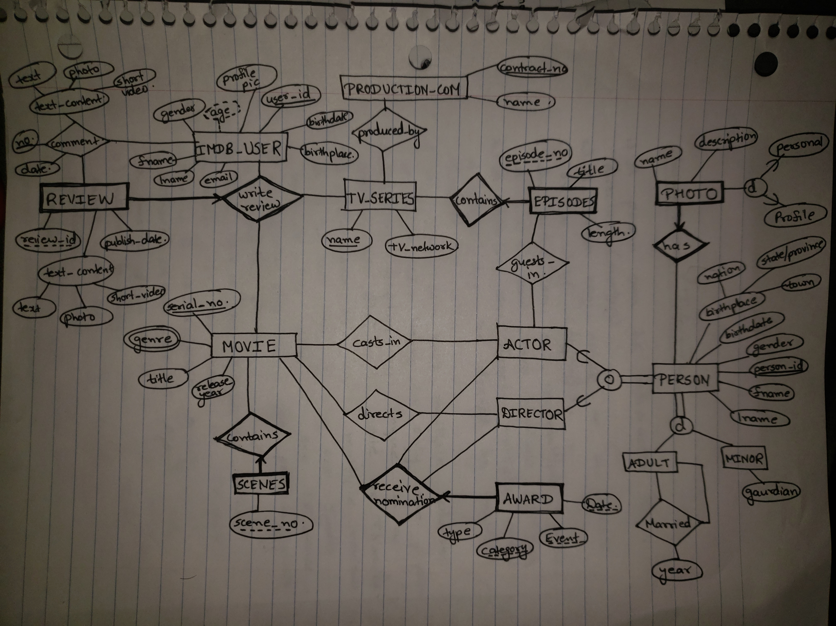

**Assumptions:**

